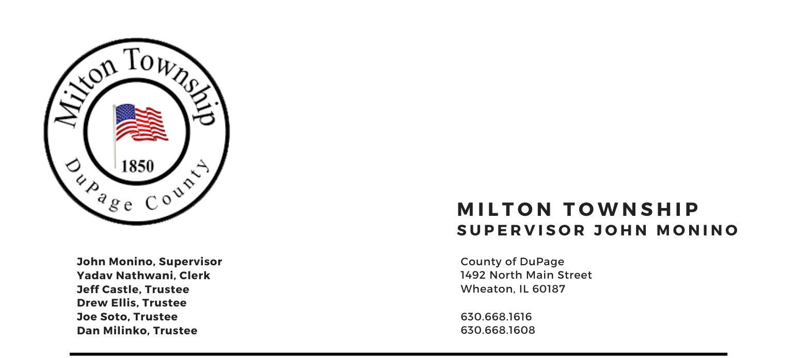

**Tuesday, August 13th 2024**

6:15 p.m. – Audit of Township Bills/Claims Board Room, Milton Township Hall

6:30 p.m. –Regular Monthly Business Meeting 1492 N. Main Street

Wheaton, Illinois 60187

_____________________________________________________________________________________

AGENDA

I. Call to Order (**Invocation Chaplin Jim Devitt**)

A. Pledge of Allegiance

B. Attendance Roll Call

C. Approval of Agenda

D. Approval of Minutes of Regular Meeting on July 9th, 2024

E. Approval of Claims

II. Public Forum - A time for the public to voice comments and concerns

III. Chairman's Report

1. General Assistance Dept.
2. Decennial Meeting Sept 10th 5:00pm Milton Township Office
3. Newsletter Updates July/August
4. Memorial Park Concert for Milton Township Food Pantry
5. Milton Township 708 Milton Mental Health Board (Bob Lyons)
6. Miscellaneous/Other

IV. Reports

1. Town Clerk Reports/Comments
2. Township Trustees Reports/Comments
3. Food Pantry (Dave Sezonov Executive Director) Food Pantry Meeting 09/10/2024 5:45pm

D. CERT (Dave Sezonov, Executive Director)

E. S.A.L.T. Committee (Chuck Smith, Chairman)

F. Cemeteries Authority (Monino / Ellis) / St. Stephens Cemetery Event August 31st, 2024, 11:00am

G. Transportation (Marty Keller, Executive Director)

V. Unfinished Business

A. Discussion of Pleasant Hill Fence (3bids)

VI. New Business

1. Milton Township Elected Officials Salary Discussion
2. Milton Township Parking Policy
3. Tax Objection Approval
4. Pelego Web Site Management Presentation

VII. Adjournment

Signed: Yadav Nathwani Date: 08/06/2024

Yadav Nathwani, Town Clerk

* * * * * * * * * * * * * * * * * * * * * * * * * * * *