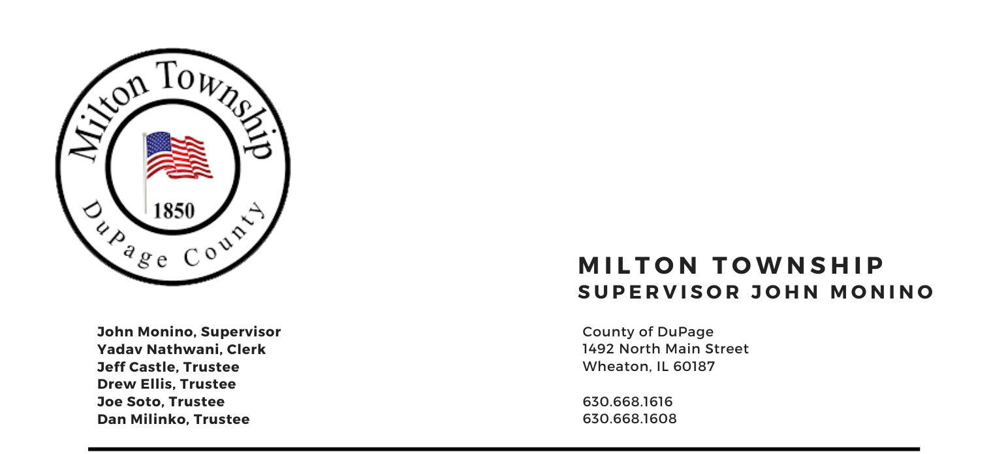

Tuesday, February 13, 2024
5:30 p.m. - 708 Board Contract Award Presentation
6:15 p.m. – Audit of Township Bills/Claims Board Room, Milton Township Hall
6:30 p.m. –Regular Monthly Business Meeting 1492 N. Main Street
Wheaton, Illinois 60187
_____________________________________________________________________________________
AGENDA

- Call to Order
Invocation: Chaplin Jim Devitt
- Pledge of Allegiance
- Moment of Silence for Kevin Mazzuca (CERT Member & Trustee Castle’s Father In-Law)
C. Roll Call
D. Approval of Agenda
E. Approval of Minutes of Regular Meeting for Tuesday, January 9, 2024
F. Approval of Claims $918,618.93.

II. Public Comment – Comment from the Public (Limited to 3 Minutes)
III. Chairman's Report
- General Assistance
- Newsletter Update April/May Issue
- Carol Stream Quarterly Meeting
- Miscellaneous Items

IV. Reports
- Town Clerk
- Food Pantry (Dave Sezonov, Executive Director)
C. CERT (Dave Sezonov, Executive Director)
D. S.A.L.T. Committee (Chuck Smith, Chairman)
E. Cemeteries Authority (Monino /Ellis)
F. Trustees

V. Unfinished Business
A. None

VI. New Business
- Approval of Intergovernmental Agreement with DuPage County Sheriff’s Department for Special Police Services
- Township Organizational Chart Review and Approve
- Township Employee Job Descriptions Review and Approve
- Approval/Ratification of an Intergovernmental Agreement between Milton Township C.E.R.T and the Winfield Township Highway Department for Events and Training
- Presentation/Review Draft Agenda Policy
- Presentation of Preliminary Budget 2024-2025(Discussion only)

VII. Executive Session
A. For the purpose of discussing the appointment, employment, compensation, discipline,
performance or dismissal of specific employees of the public body, in accordance with 5 ILCS 120/2(c)(1)
B. For purpose of discussion Leasing of Public Property, in accordance with 5 ILCS 120/2(c)(5)

VIII. Adjournment
Signed: Yadav Nathwani Date: 02/08/2024
Yadav Nathwani, Town Clerk

* * * * * * * * * * * * * * * * * * * * * * * * * * *

