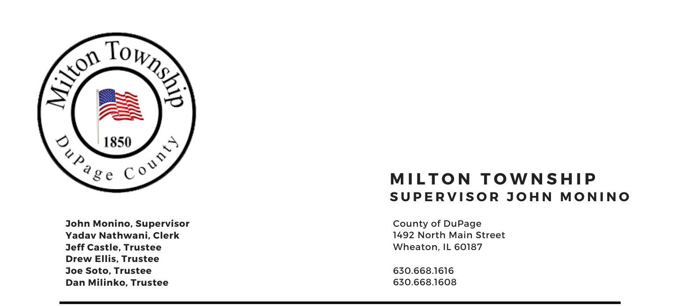
January 9th 2024

6:15 p.m. – Audit of Township Bills Board Room, Milton Township Hall
6:30 p.m. – Regular Monthly Business Meeting 1492 N. Main Street
Wheaton, Illinois 60187
_____________________________________________________________________________________

AGENDA

I. Call to Order
II. Invocation Chaplin Jim Devitt
A. Pledge of Allegiance
B. Attendance Roll Call
C. Approval of Minutes of Regular Meeting on Tuesday December 12, 2023
D. Approval of Agenda
E. Approval of Claims

III. Public Comment – Comment from the Public (Limited to 3 Minutes)

IV. Chairman's Report
A. Budget Meetings February
B. Milton Toy Drive
C. Seniors Luncheon VFW 01/08/2024
D. Food Pantry/ Assessors - Parking at Township
E. Midwest Shelter for Homeless Veterans – Rotary Wheaton
F. Miscellaneous/Other

V. Reports
A. Town Clerk (Yadav Nathwani)
B. Food Pantry (Dave Sezonov Executive Director)
C. CERT (Marty Keller, Executive Director)
D. S.A.L.T. Committee (Chuck Smith, Chairman)
E. 708 Board (Shannon Hartnett President)
F. Cemeteries Authority (Monino / Ellis) – Fence and Burial Pleasant Hill
G. Trustees (Castle, Ellis, Soto, Milinko)

VI. Unfinished Business
A. None

VII. New Business
A. Discussion for New Facility off site for Assessors side.

VIII. Executive Session
(A.) For the purpose of discussing the appointment, employment, compensation, discipline, performance or dismissal of specific employees of the public body in accordance with 5ILCS 120/2(c)(1)

IX. Adjournment

Signed: Yadav Nathwani Date: 01/03/2024

Yadav Nathwani, Town Clerk

* * * * * * * * * * * * * * * * * * * * * * * * * * * *

