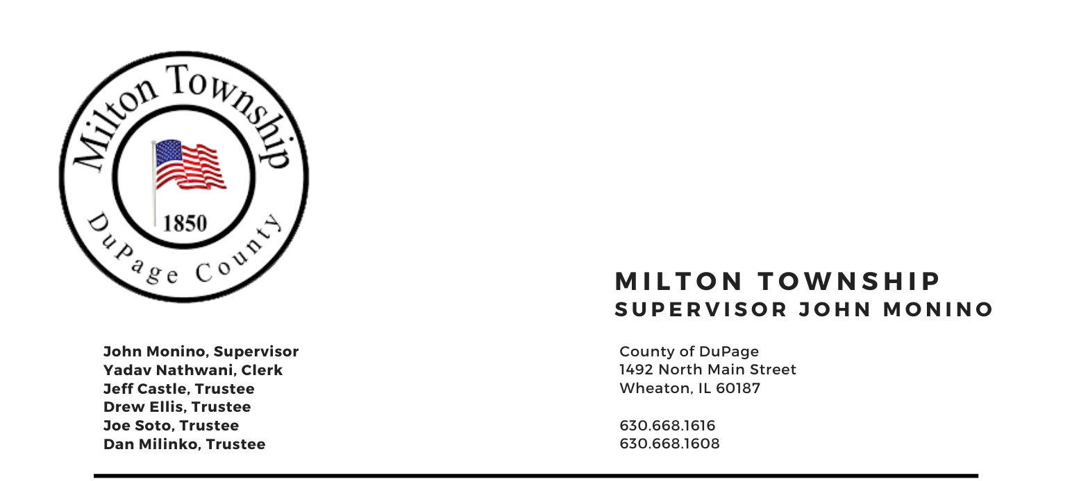
December 12, 2023

6:15 p.m. – Audit of Township Bills Board Room, Milton Township Hall
6:30 p.m. – Regular Monthly Business Meeting 1492 N. Main Street
Wheaton, Illinois 60187
_____________________________________________________________________________________

AGENDA

I. Call to Order
II. Invocation Chaplin Jim Devitt
A. Moment of Silence Former Senate President James “PATE” Phillip
B. Pledge of Allegiance
C. Attendance Roll Call
D. Approval of Minutes of Regular Meeting on Tuesday November 14th and Special Meeting November 22nd
E. Approval of Agenda

III. Public Comment – Comment from the Public (Limited to 3 Minutes)

IV. Chairman's Report
A. General Assistance Dept.
B. Toys for Tots Pickup
C. Seniors Luncheon Wyndemere Senior Living
D. Miscellaneous/Other

IV. Reports
A. Town Clerk
B. Food Pantry (Dave Sezonov Executive Director)
C. CERT (Marty Keller, Executive Director)
D. S.A.L.T. Committee (Chuck Smith, Chairman)
E. 708 Board (Shannon Hartnett President)
E. Cemeteries Authority (Monino / Ellis)
F. Trustees

V. Unfinished Business
A. Adoption of Levy: Road District Fund – Ordinance No. O-23-07 (RATIFICATION)
B. Adoption of Levy: Special Police District Fund – Ordinance No. O-23-08 (RATIFICATION)
C. Adoption of Levy: Consolidated Milton/Glen Ellyn Mosquito Abatement Fund – Ordinance No. O-23-09 (RATIFICATION)
D. Adoption of Levy: Town & General Assistance Funds – Ordinance No. O-23-10 (RATIFICATION)
E. Adoption of Levy: 708 Board – Ordinance No. O-23-11 (RATIFICATION)

VI. New Business

A. 708 Mental Health Board Appointments
B. A Resolution of the Board of Trustees of Milton Township, DuPage County, Illinois Providing for and Requiring the Submission of a Public Question to allow for Township Authority to Contract for the Disposal of Garbage, Refuse and Recycling to be Submitted to the voters of the Township at the General Primary election to be Held on March 19, 2024. Resolution R-23-7
C. Contract for Clarke Mosquito Control and Management
D. Insurance Information Presentation: Mike Dyer

VII. Adjournment

