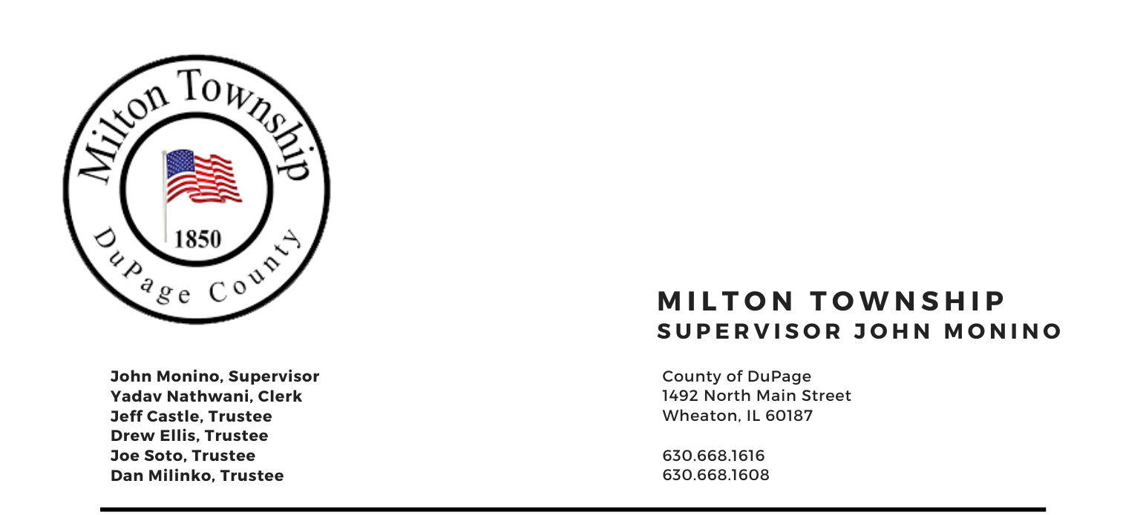

Tuesday, November 14th 2023

6:15 p.m. – Audit of Township Bills Board Room, Milton Township Hall
6:30 p.m. –Regular Monthly Business Meeting 1492 N. Main Street
Wheaton, Illinois 60187
-------------------------------------------------------------------------------------------------------------------------------------------

AGENDA
- Call to Order
- Moment of Silence for Bob Jacobsen
- Invocation
A. Pledge of Allegiance
B. Attendance Roll Call
C. Approval of Agenda
D. Approval of Minutes of Regular Meeting on Tuesday, October 10th 2023
E. Approval of Claims
F. Proclamation for the Wheaton Lions Club 100 year Anniversary

IV. Public Forum - A time for the public to voice comments and concerns

V. Chairman's Report
- General Assistance Department –
- Mosquito Abatement Wheaton Decennial
- Seniors Luncheon’s Thanksgiving 11/17/23 & Christmas
- Closing of the Assessment Books
- 708 Mental Health Meeting “Mobilizing for Recovery”
- Miscellaneous

VI. Reports
- Town Clerk
B. Seniors Committee (Chuck Smith, Chairman)
C. Cemeteries Authority Monino- Ellis
D. Citizen Corps & CERT – (Marty Keller)
E. Food Pantry Dave Sezonov
F. 708 Mental Health Board
G. Trustees Comments (if any)

VII. Unfinished Business
- None

VIII. New Business
- Special Meetings Dates To Determine Tax Levy 11/21/2023 & 11/28/2023 if needed - 2024 Highway Department Funds, Special Police District Fund, 708 Board Fund, Mosquito Abatement District Fund, Town & General Assistance Funds
- Board Meeting Dates –Resolution No. R-20-4
- 2024 Holiday Schedule – Resolution No. R-20-5
- Miscellaneous/Other

IX. A. Adjournment

Signed: Yadav Nathwani Date: 11/08/2023
Yadav Nathwani, Town Clerk

