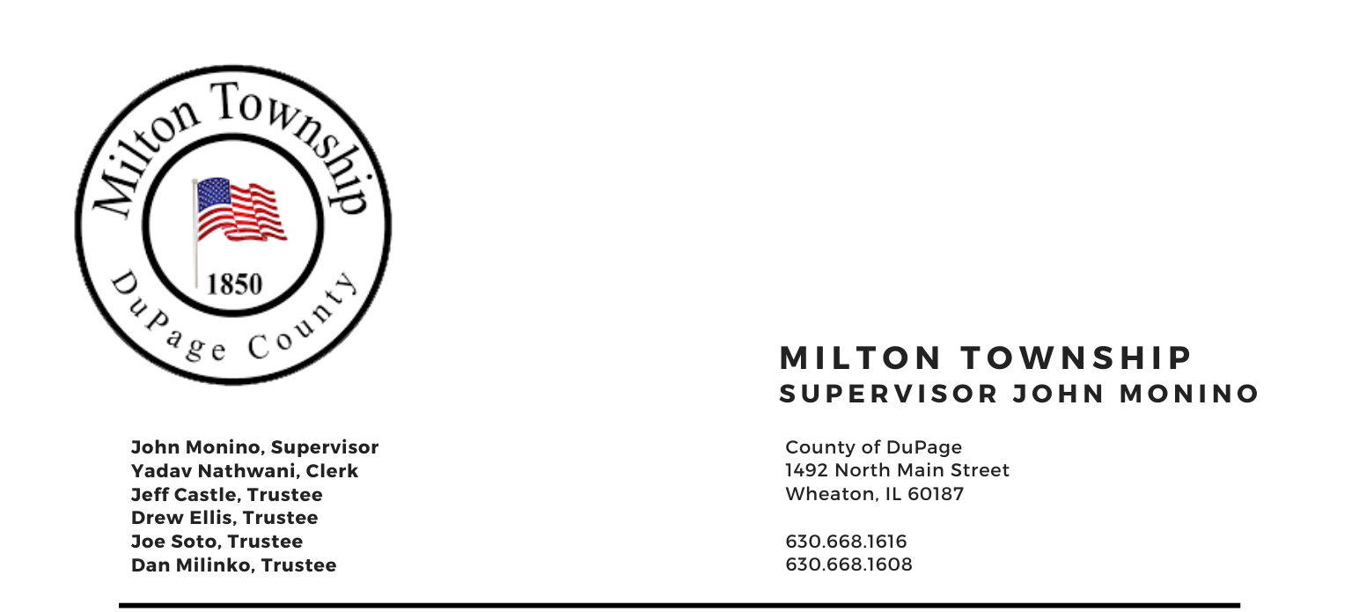

NOTICE OF
SPECIAL TOWNSHIP BOARD MEETING

Tuesday Feb 1st, 2022

6:30 P.M.
Board Room, Milton Township Hall
1492 N. Main Street
Wheaton, Illinois 60187
_____________________________________________________________________________________

AGENDA
6:30 PM –

- Call to Order
A. Pledge of Allegiance
- Attendance Roll Call
- Approval of Agenda

- Strategic & Capital Planning Workshop
  - Strategic Priorities
  - Goals
  - Strategies
  - Capital Projects Fund Discussion and Planning

- Unfinished Business
  - None

- New Business
    - None

- Adjournment

Signed: Yadav Nathwani Date: 1/28/2022
Yadav Nathwani, Town Clerk

* * * * * * * * * * * * * * * * * * * * * * * * * * * *

