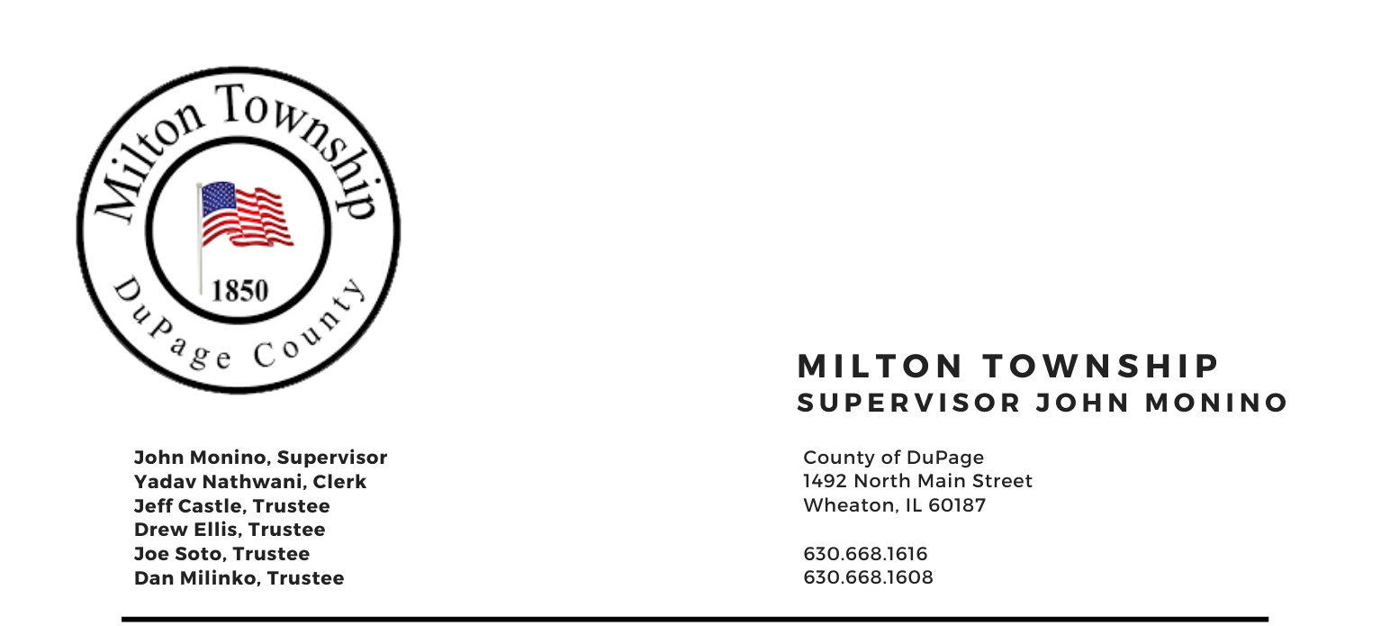

NOTICE OF
SPECIAL TOWNSHIP BOARD MEETING

Tuesday, January 18th 2022

6:30 P.M.
Board Room, Milton Township Hall
1492 N. Main Street
Wheaton, Illinois 60187
_____________________________________________________________________________________

AGENDA
6:30 PM –

- Call to Order
A. Pledge of Allegiance
- Attendance Roll Call
- Approval of Agenda

- Chairman’s Report
    - Miscellaneous/Other

- Unfinished Business
  - None

- New Business
    - Approval of Assessor’s Budget fiscal year 2022

- Adjournment

Signed: Yadav Nathwani Date: 1/13/2022
Yadav Nathwani, Town Clerk

* * * * * * * * * * * * * * * * * * * * * * * * * * * *

