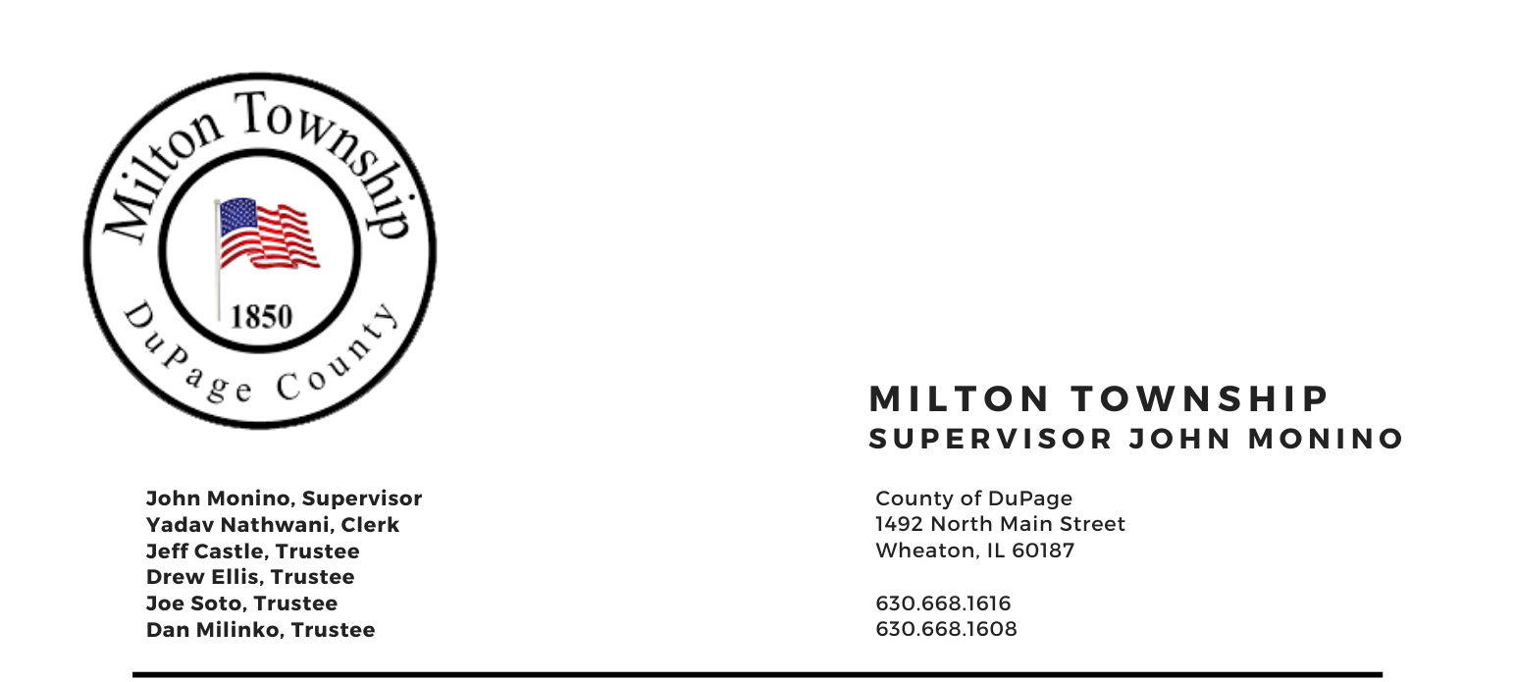

TUESDAY – January 11TH 2022

6:15 p.m. – Audit of Township Bills/Claims Board Room, Milton Township Hall
6:30 p.m. –Regular Monthly Business Meeting 1492 N. Main Street
Wheaton, Illinois 60187
_____________________________________________________________________________________

AGENDA

- Call to Order
A. Pledge of Allegiance
- Attendance Roll Call
- Approval of Agenda
- Approval of Minutes of Regular Meeting on December 14, 2021 & Special Meeting on December 21, 2021
- Approval of Claims

- Public Forum – A time for the public to voice comments and concerns (limited to 3 minutes)

- Chairman’s Report
  - General Assistance Dept. & Food Pantry
  - MICROBE-USA Systems and quotes
  - Miscellaneous/Other

- Officials & Committee Reports
  - Town Clerk
  - CERT (Marty Keller, Executive Director)
  - Seniors Committee (Chuck Smith, Chairman)
  - Cemeteries Authority (Drew Ellis)
  - Trustees

- Unfinished Business
    - Audit Updates

- New Business
    - Capital Projects/Discussion of Future Building Plans and Improvements
    - Miscellaneous/Other

- Adjournment

Signed: Yadav Nathwani Date: 1/7/2022
Yadav Nathwani, Town Clerk

* * * * * * * * * * * * * * * * * * * * * * * * * * * *

