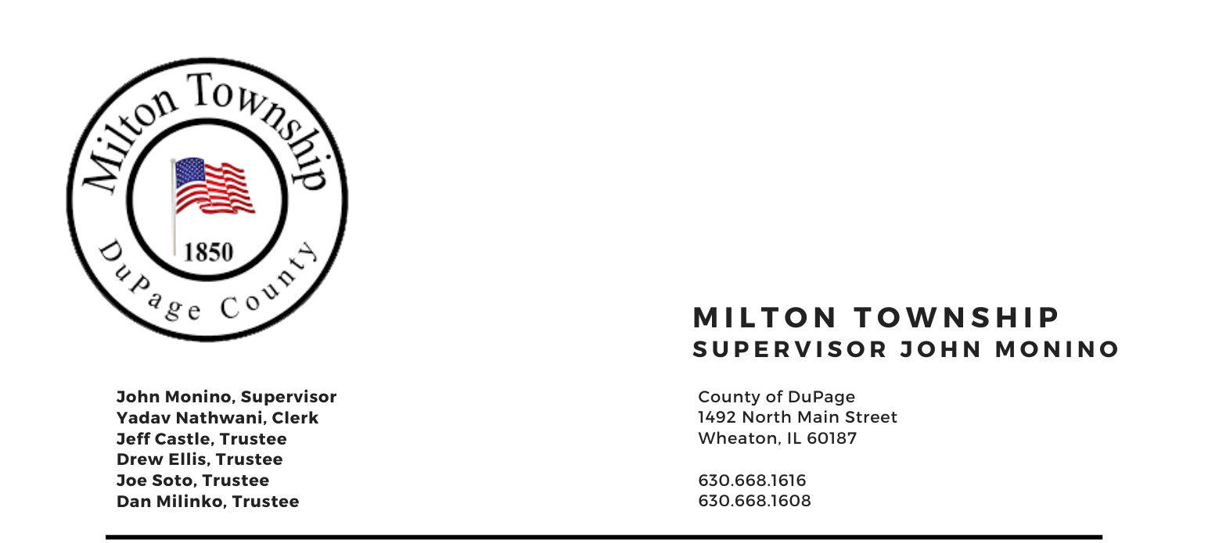

NOTICE OF PUBLIC HEARING AND
SPECIAL TOWNSHIP BOARD MEETING

WEDNESDAY – DECEMBER 22, 2021

6:30 P.M.
Board Room, Milton Township Hall
1492 N. Main Street
Wheaton, Illinois 60187
_____________________________________________________________________________________

6:30 PM - Public Hearing

- PUBLIC HEARING

PUBLIC HEARING ON THE TOWNSHIP’S INTENT TO ADOPT AN AGGREGATE LEVY IN AN AMOUNT MORE THAN 105% OF THE AMOUNT EXTENDED UPON THE FINAL AGGREGATE LEVY EXTENSION FOR THE CORPORATE AND SPECIAL PURPOSE LEVY FOR THE PRECEDING FISCAL YEAR.

IMMEDIATELY FOLLOWING PUBLIC HEARING: SPECIAL MEETING AGENDA

- Call to Order
A. Pledge of Allegiance
- Attendance Roll Call
- Approval of Agenda

- Chairman’s Report
    - Creation of AD-HOC Committee
    - Miscellaneous/Other

- New Business
    - Adoption of Ordinance No. O-21-6: Road District Levy
    - Adoption of Ordinance No. O-21-5: Special Police District Levy
    - Adoption of Ordinance No. O -21-4:Consolidated Milton/Glen Ellyn Mosquito Abatement Levy
D. Adoption of Ordinance O-21-3 - Town, CMHB and General Assistance levy

- Adjournment

Signed: Yadav Nathwani Date: 12/20/2021
Yadav Nathwani, Town Clerk

* * * * * * * * * * * * * * * * * * * * * * * * * * * *

