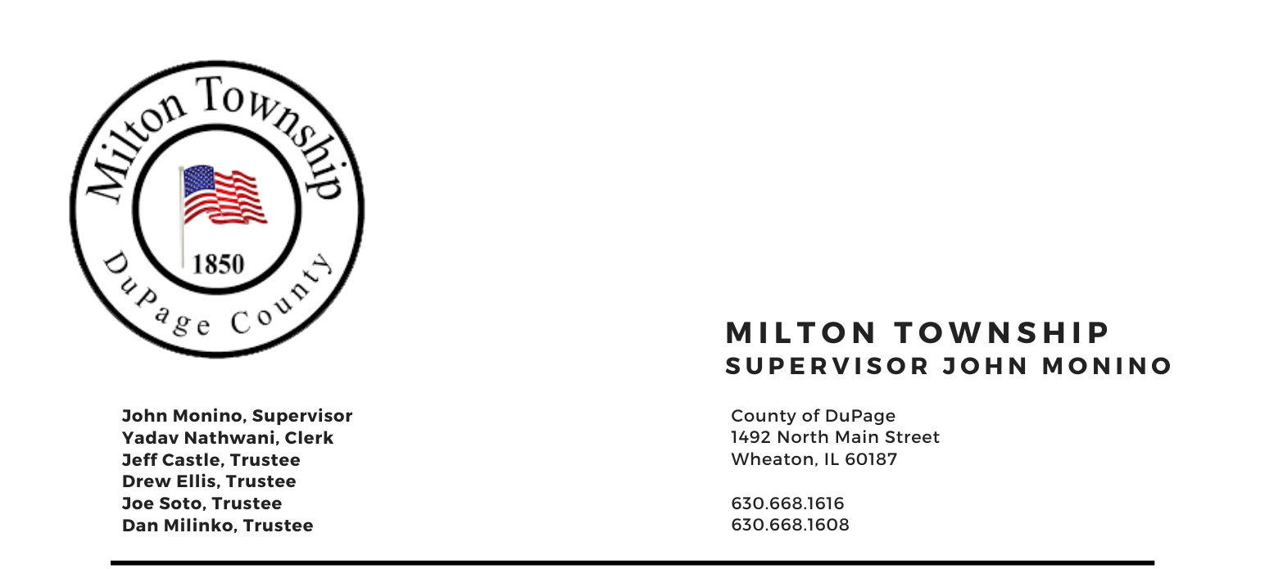

TUESDAY –November 9th 2021

6:15 p.m. – Audit of Township Bills Board Room, Milton Township Hall
6:30 p.m. –Regular Monthly Business Meeting 1492 N. Main Street
Wheaton, Illinois 60187
-------------------------------------------------------------------------------------------------------------------------------------------

AGENDA
I. Call to Order
A. Pledge of Allegiance
B. Attendance Roll Call
C. Approval of Agenda
D. Approval of Minutes of Regular Meeting on October 12th 2021
E. Approval of Minutes of Special Meeting on November 2nd 2021
F. Approval of Claims

II. Public Forum - A time for the public to voice comments and concerns

III. Chairman's Report
- Proclamation for Bob Jacobsen- Cemetery Authority
- General Assistance Department & Food Pantry
- Mosquito Abatement/ WNV
- Closure of the Books Assessor Dept.
- Miscellaneous/Other

IV. Reports
- Town Clerk
B. S.A.L.T. Committee (Chuck Smith, Chairman)
C. Cemeteries Authority (John Monino, Drew Ellis)
D. Citizen Corp & CERT – (Marty Keller)
E. 708 Board Presentation
F. Trustees

V. Unfinished Business
A. Audit (Follow-up)
B. Miscellaneous/Other

VI. New Business
A. Resolution No. 2021-10 A Resolution Authorizing an Agreement with the Township Road District for Employee Cost Sharing
B. 2022 Board Meeting Dates – Resolution No. R-21-11
C. 2022 Holiday Schedule – Resolution No. R-21-12
D. Tentative 2022-23 Levies for the Following Funds:
1. Highway Department Funds
2. Special Police District Fund
3. Mosquito Abatement District Fund
4. Town & General Assistance Fund
5. Community Mental Health (708 Board)
6. Miscellaneous/Other

VII. Adjournment

Signed: Yadav Nathwani Date: November 9th 2021
Yadav Nathwani, Town Clerk

