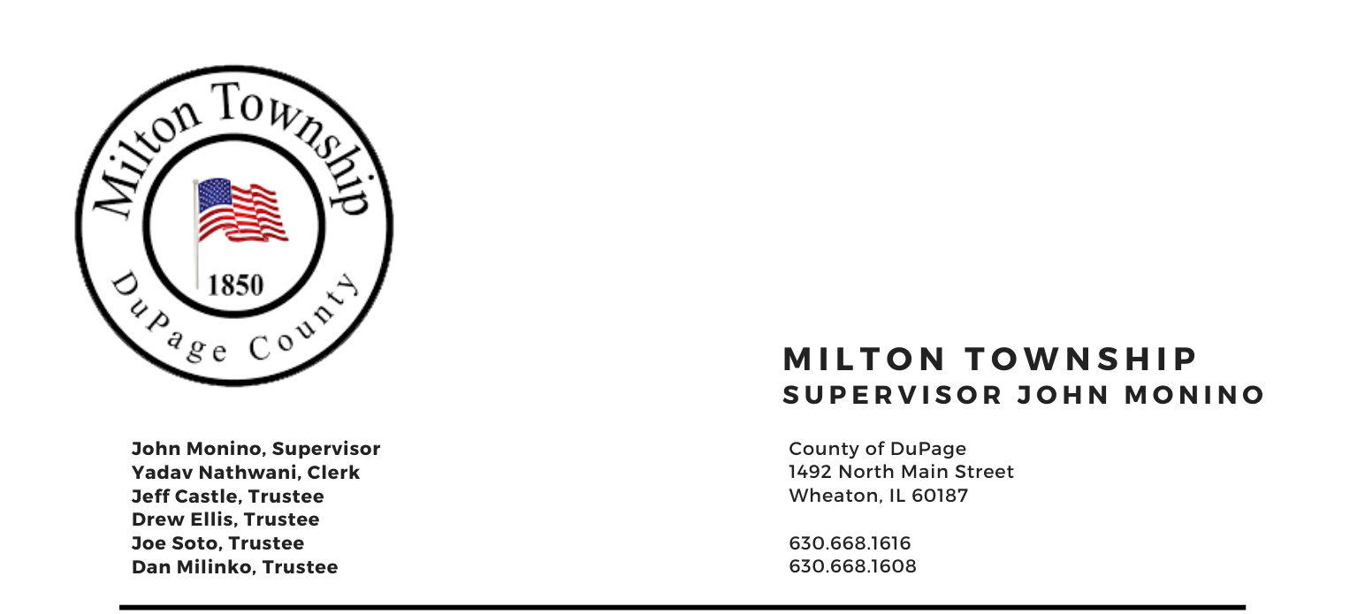

TUESDAY – September 14, 2021

6:15 p.m. - Audit of Township Bills Board Room, Milton Township Hall 6:30 p.m. - Regular Monthly Business Meeting 1492 N. Main Street
Wheaton, Illinois 60187

AGENDA

- Call to Order
- Pledge of Allegiance
- Attendance Roll Call
- Approval of Agenda
- Approval of Minutes of Regular Meeting on August 10, 2021
- Approval of Claims

- Public Forum – A time for the public to voice comments and concerns

- Chairman’s Report
- General Assistance /Food Pantry
- M.A.D.s & W.N.V. (Mosquito Abatement & West Nile Virus)
- Presentation of Annual Treasurer’s Report (if available)
- Weed program
- Miscellaneous/Other

- Report
- Town Clerk
- Seniors Committee (Chuck Smith, Chairman)
- Cemeteries Authority (Drew Ellis)
- Citizen Corps & CERT (Marty Keller)
- Trustee’s Comments (if any)

- Unfinished Business
- Audit status (acceptance, if done)

- New Business
- A. Resolution NO. 2021- A Resolution Ratifying Employment of Township Employees and Various Contracts
- Appointment of Deputy Clerk

- Executive Session – Semi-annual Review of Executive Session Minutes pursuant to 5 ILCS 120/2(c) (21) and 120/2.06(d).

- Adjournment

Signed: Yadav Nathwani Date: September 7, 2020
Yadav Nathwani, Town Clerk

