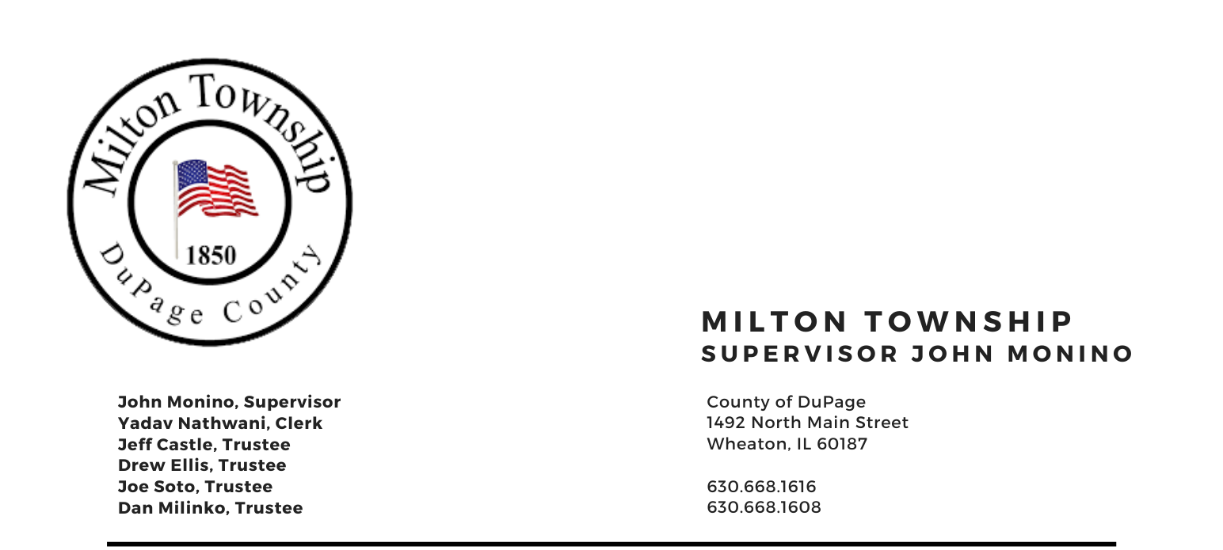
Tuesday, January 14th 2025

6:15 p.m. – Audit of Township Bills/Claims Board Room, Milton Township Hall
6:30 p.m. –Regular Monthly Business Meeting 1492 N. Main Street
Wheaton, Illinois 60187
_____________________________________________________________________________________
AGENDA
Invocation Chaplain Jim Devitt
- Call to Order
A. Pledge of Allegiance
- Attendance Roll Call
- Approval of Agenda
- Approval of Minutes of Regular Meeting on Tuesday, December 10th, 2024
- Approval of Claims
- Public Comment – A time for the public to voice comments and concerns (limited to 3 minutes)
- Chairman’s Report
  - Newsletter - Emmy
  - Seniors Luncheon
  - Miscellaneous/Other
- Officials & Committee Reports
  - Town Clerk
  - CERT (Dave Sezonov, Executive Director)
  - Food Pantry (Dave Sezonov, Executive Director)
  - SALT (Chairman Chuck Smith)
  - 708 Mental Health Board (President Shannon Hartnett)
  - Cemeteries Authority (Drew Ellis)
- Unfinished Business
    - Approval of Website Redevelopment
- New Business
    - Setting of Annual Meeting Agenda and consideration of agenda items
    - 708 Board Vote on moving 7 Members to 9 Member Board (If Passed Vote on two Appointments 1) Christine Platt 2) Rita Brosman
    - 708 Board Retro 1/01/2025 Reappointments Drew Ellis and Shannon Harnett
    - 708 Board Appointment of Sarah O’Donnell (Replacement of Kara Murphy)
    - Approval of Special Police Intergovernmental Assignment Agreement 2025
    - Discussion / Budget Workshop

- Adjournment

Next Meeting February 11th 2024

Signed: Yadav Nathwani Date: 01/10/2025
Yadav Nathwani, Town Clerk

* * * * * * * * * * * * * * * * * * * * * * * * * * * *

